1. Q

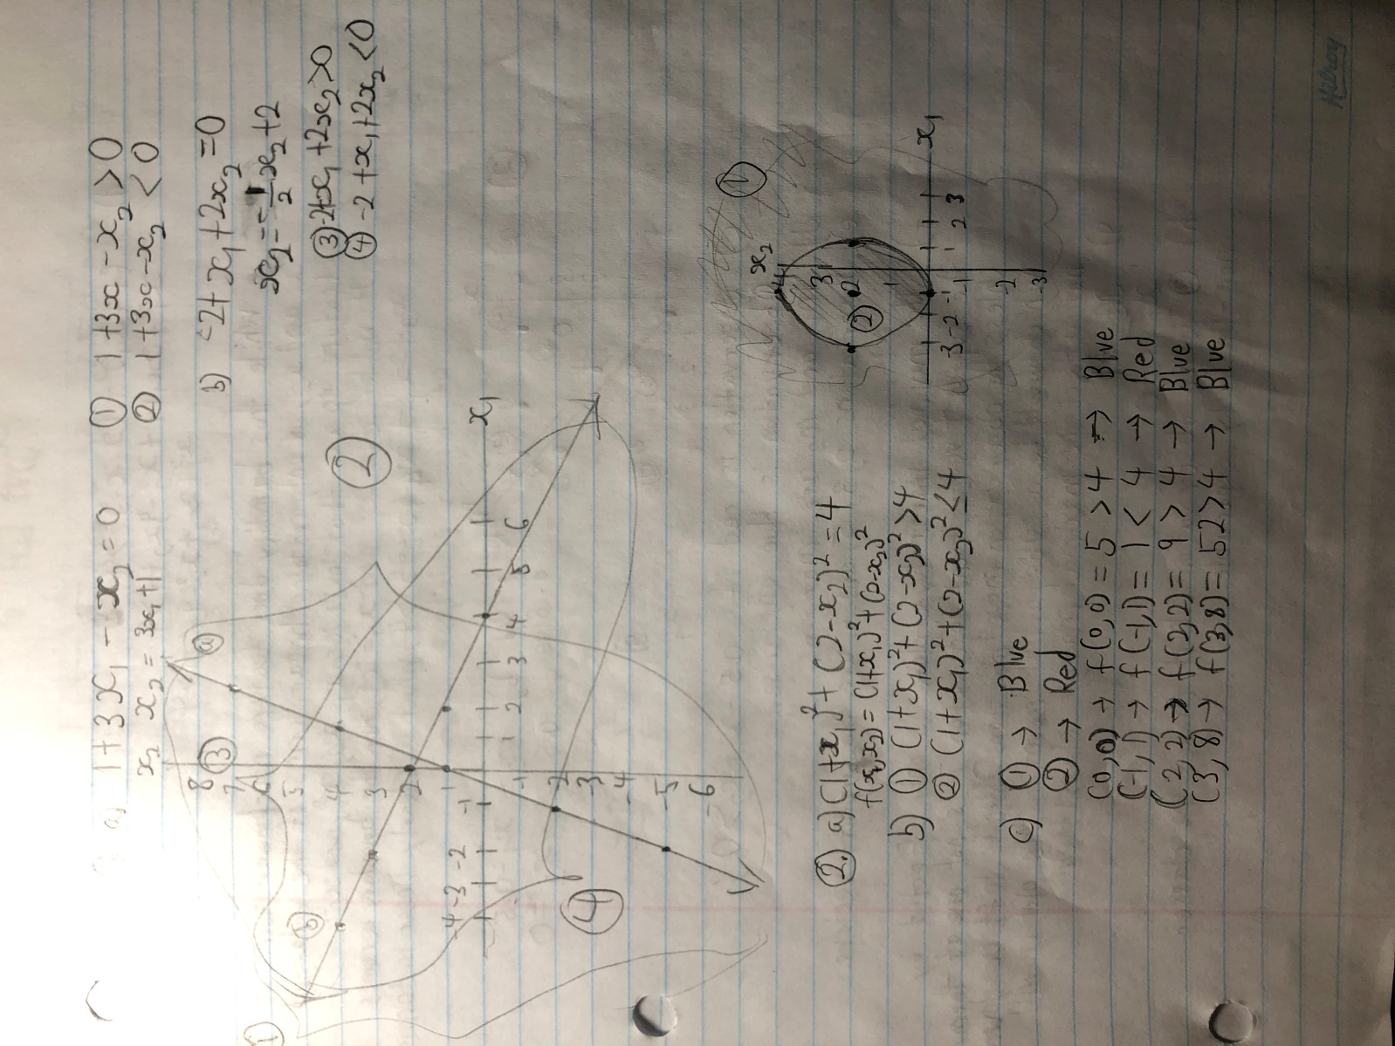

1. Linear Decision Boundary

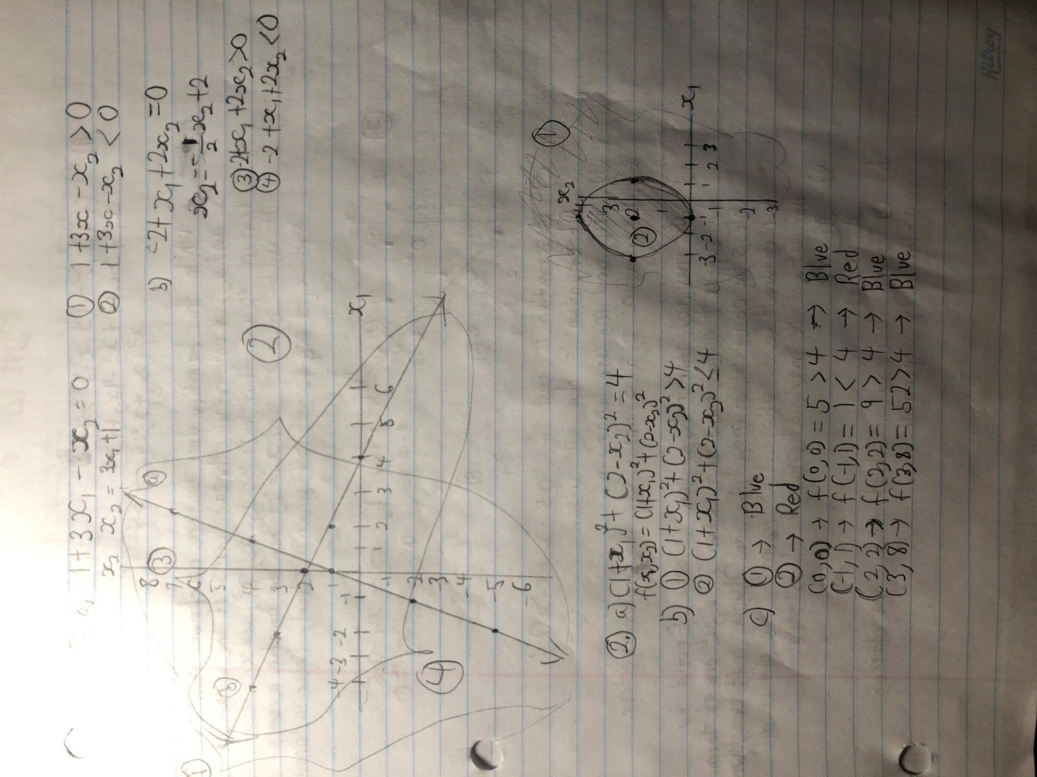

* 1. While this boundary does feature non-linear terms of and , it only contains linear terms of the enlarged feature space that includes and . If we let and , then the boundary becomes , which is clearly linear in terms of these 4 predictors.

1. Maximal Margin Classifier
   1. Graph

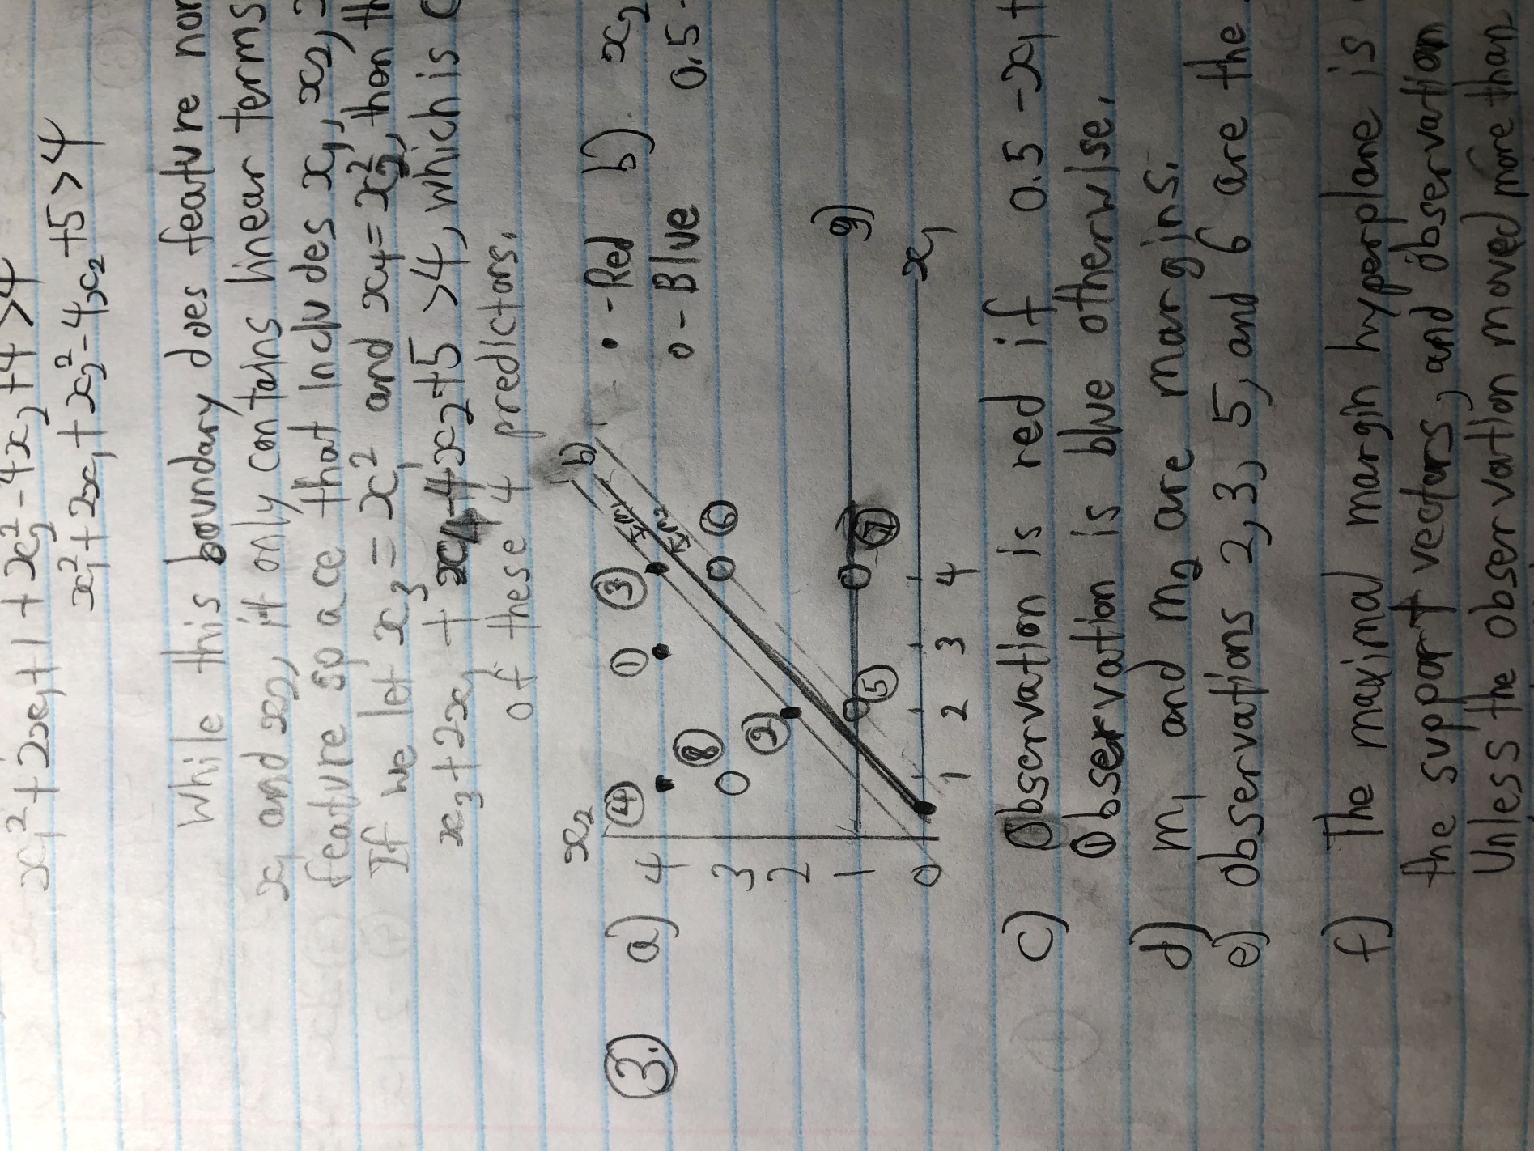

* 2. Observation is red if , and blue otherwise.
  3. and are the margins on the diagram.
  4. Observations and are the support vectors.
  5. The maximal margin hyperplane is only affected by the support vectors, and observation is not one of them. Unless the observation moved more than 2 units left or down, which would be a substantial amount for a plot of this scale, it would not affect the maximal margin classifier.
  6. is an observation which makes the classes non-linearly separable.